

**LG TP-C488TLV0**

**Rs. 128,000/-**

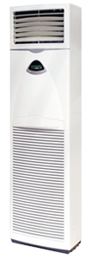

**Product Features**

* Low Noise Air Flow System
* Easy Clean Panel
* Remote Control Pocket
* Three Minutes Protection
* Rust Resistant Cabinet

**Specification**

**Type** Wall Mounted Split AC

**Cooling (Btu/h)** 33000

**Voltage (V)** 220-240

**Power Input (W)** 3600

**EER (Btu/W-h-W/W)** 6.1-2.5